Impartiality and Appearance of Conflict—5 CFR §§2635.501-503

Basic Prohibition

There may be circumstances in which employees should not perform official duties in order to avoid an appearance of loss of impartiality. Subpart E of the Standards of Ethical Conduct, at 5 C.F.R § 2635, contains two disqualification provisions addressing those appearance issues.

Personal and Business Relationships

The first provision, entitled “Personal and business relationships,” states that employees should not participate in certain Government matters where their impartiality is likely to be questioned. The matters specifically covered by this standard include:

- Particular matters involving specific parties, such as contracts, grants, or investigations;

  - That are likely to affect the financial interests of members of employees’ households; or

  - In which persons with whom employees have “covered relationships” are parties or represent parties to the specific party matter. This would include, for example, matters involving recent employers, employers of spouses or dependent children, or anyone with whom the employees have or seek a business or financial relationship.

Employees may also disqualify themselves in circumstances other than those described above if they believe a reasonable person with knowledge of the relevant facts would question their impartiality in the matter.

Extraordinary Payments from Former Employer

The second provision, entitled “Extraordinary payments from former employers,” restricts employees’ participation in certain matters involving former employers. If a former employer gave an employee an “extraordinary payment” in excess of $10,000 prior to entering Federal service, it bars the employee from participating for two years in matters in which that former employer is a party or represents a party.

Elements of 5 C.F.R. section 2635.502
Key Elements
- Employee
- Particular Matter Involving Specific Parties
- Covered Relationship
- Is or Represents a Party
- Financial Interest of Household Member
- Direct and Predictable Effect
- Reasonable Person

* This is only a summary. When giving advice, always consult the complete set of rules and opinions that apply to the particular situation.

The Process

Personal and Business Relationships Recusal Process
Personal and Business Relationships Recusal Process
Covered Relationship  5 CFR § 2635.502(a) | 502 Financial Interests  5 CFR § 2635.502(a) | Other Appearances  5 CFR § 2635.502(a)(2)
Is there a particular matter involving specific parties? | Is there a particular matter involving specific parties? | Are circumstances such that a reasonable person with knowledge of the relevant facts would question the employee’s impartiality? (optional)
Does the employee have a covered relationship with anyone who is a party or represents a party to the matter? | Is the matter likely to have a direct and predictable effect on a household member’s financial interest?
Would a reasonable person with knowledge of the relevant facts question the employee’s impartiality? | Would a reasonable person with knowledge of the relevant facts question the employee’s impartiality?

Employee

Subpart E of the Standards of Ethical Conduct applies to all Executive branch employees except the President, and Vice President (See 5 C.F.R. § 2635.102(h)), including:

- Full-time “officers” and “employees” of the Executive branch, regardless of grade or rank (except as stated above)
- Part-time employees, including special government employees (SGEs), whether or not compensated;
- “Detailees” under the Intergovernmental Personnel Act; (See 5 U.S.C. §§ 3371-3376)

The regulation does NOT apply to contractor employees.

Particular Matter Involving Specific Parties
See 5 CFR 2641.201(h)

Particular matter means any matter that involves "deliberation, decision, or action that is focused upon the interests of specific persons, or a discrete and identifiable class of persons." A particular matter involving specific parties is a subset of particular matter.

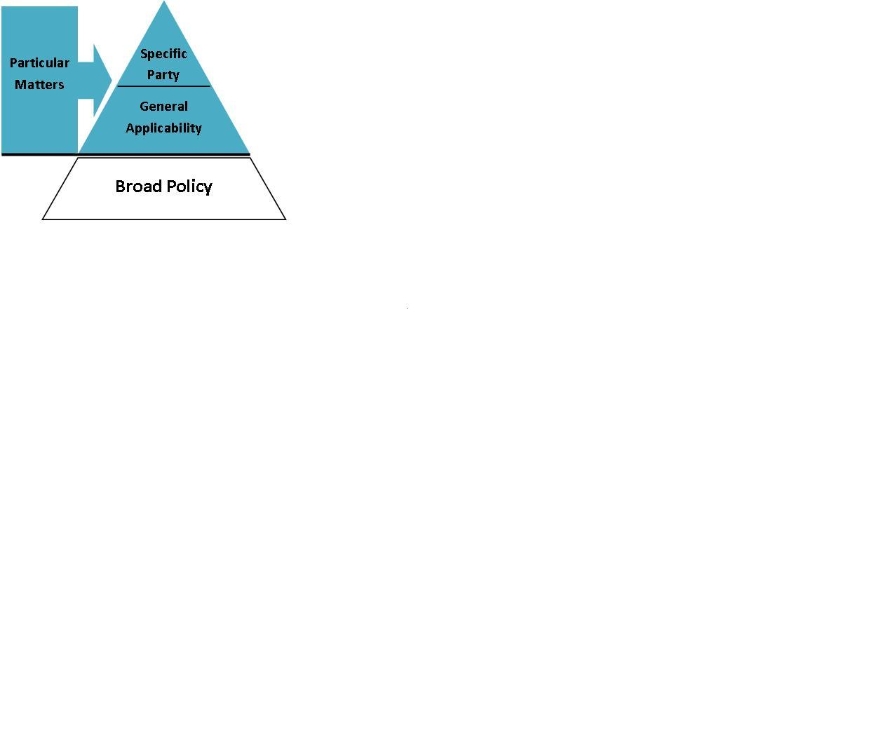
A particular matter involving specific parties typically involves:

- Specific proceedings affecting the legal rights of the parties; e.g. judicial proceedings or requests for a ruling or other determinations, such as immigration or tax hearings

- Isolatable transactions or a related set of transactions between identified parties; e.g., contracts, grants, licenses, product approvals, applications, enforcement actions, administrative adjudications, or court cases.

For further elaboration, see OGE Advisory Memo 06 x 9 of October 4, 2006 titled, "Particular Matter Involving Specific Parties," "Particular Matter," and "Matter."

Covered Relationship
5 C.F.R. §2635.502(b)(1)

For purposes of the disqualification requirements in section 2635 .502, an employee is deemed to have a “covered relationship” with the following:

Covered Relationships
- A person with whom the employee has or seeks a business, contractual, or other financial relationship that involves other than a routine transaction
NOTE: This definition does NOT include a prospective employer described in § 2635.603. An employee seeking employment shall comply with Subpart F instead of this section.

- A person who is a member of the employee’s household

- A relative with whom the employee has a close personal relationship

- A person for whom the employee’s spouse, parent or dependent child is, to the employee’s knowledge, serving or seeking to serve as an officer, director, trustee, general partner, agent, attorney, consultant, contractor or employee

- Any person for whom the employee has, within the last year, served as officer, director, trustee, general partner, employee, agent, attorney, consultant or contractor

- Any organization, other than a political party, in which the employee is an active participant.

Reasonable Person

Before an employee may participate either in a specific party matter in which someone with whom he has a covered relationship is or represents a party OR one that is likely to have a direct and predictable effect on the financial interest of a member of his household, he MUST ask:

Would a reasonable person with knowledge of the relevant facts question his impartiality in the matter?

The “reasonable person” determination may be made either by the employee or by the agency designee. The “reasonable person” standard is that of a person armed with all of the relevant facts. An employee’s reputation for honesty and integrity is not a relevant consideration when making this determination. 5 C.F.R. §§2635.502(c) and (f)

Financial Interest of a Household Member

As with 18 U.S.C. section 208, the term “financial interest” means the potential for gain or loss as a result of governmental action on a particular matter. However, the requirements of .502 ONLY apply to the financial interests of members of the employee’s household whose financial interests are NOT already attributed to the employee under 18 U.S.C. §208.

Examples of household members whose financial interests would be covered by .502 include:
- Non-minor children
- Parents
- Roommates
- Live-in Partners
- Renters

Examples of household members whose financials interests should be analyzed under 18 U.S.C. section 208:
- Spouse
- Minor children

Direct and Predictable Effect
5 CFR §2640.103(a)(3)

A specific party matter is deemed to likely have a direct and predictable effect on a household member’s financial interest only if there is a close causal link (direct effect) between the Government matter in which the employee would participate and any effect that matter will have on the asset or other interest that creates the possibility of gain or loss to the member of the employee’s household. The effect must be real (predictable), not speculative, but it need not be probable.

Particular Matter Will…
Have a Direct Effect | Not Have a Direct Effect
If there is a close causal link:  - Between any decision or action to be taken in the matter and  - Any expected effect of the matter on the financial interest | If the chain of causation is attenuated or is contingent upon the occurrence of events that are:  - Speculative OR  - Independent of, and unrelated to, the matter
Effect does not have to occur immediately | If the effect is only as a consequence of its effects on the general economy

Particular Matter Will…
Have a Predictable Effect | Not Have a Predictable Effect
If there is a real possibility that the matter will affect the financial interest | If there is a speculative possibility that the matter will affect the financial interest
- Not necessary that the magnitude of the gain or loss be known
- Dollar amount of the gain or loss is immaterial

Remedies

Disqualification  (5 C.F.R. §2635.502(e)) | Unless an employee is authorized by an agency designee to participate in the particular matter involving specific parties, an employee shall disqualify himself from any such matter in which someone with whom he has a covered relationship is or represents a party to the matter, or which is likely to have a direct and predictable effect on the financial interest of a household member, if it is likely to raise a question in the mind of a reasonable person about his impartiality.  Disqualification is accomplished by not participating in the particular matter.
Agency Authorization  (5 C.F.R.§2635.502(d))  Authorization Standard  Factors to Consider | Where an employee’s participation in a particular matter involving specific parties would not violate 18 U.S.C. section 208, but would raise a question in the mind of a reasonable person about his impartiality, the agency designee may authorize the employee to participate in the matter.  This authorization shall be based on a determination that, in light of all the relevant circumstances, the Government’s interest in the employee’s participation outweighs the concern that a reasonable person may question the integrity of the agency’s programs and operations.  Factors may include:  1. Nature of the relationship involved;  2. Effect of the resolution of the matter on the financial interest;  3. Nature and importance of the employee’s role;  4. Sensitivity of the matter;  5. Difficulty of reassigning the matter or the employee; and  6. Adjustments that could be made to the employee’s duties to mitigate the appearance concern.

