GIFTS FROM OUTSIDE SOURCES ANALYSIS (5 CFR part 2635, Subpart B)
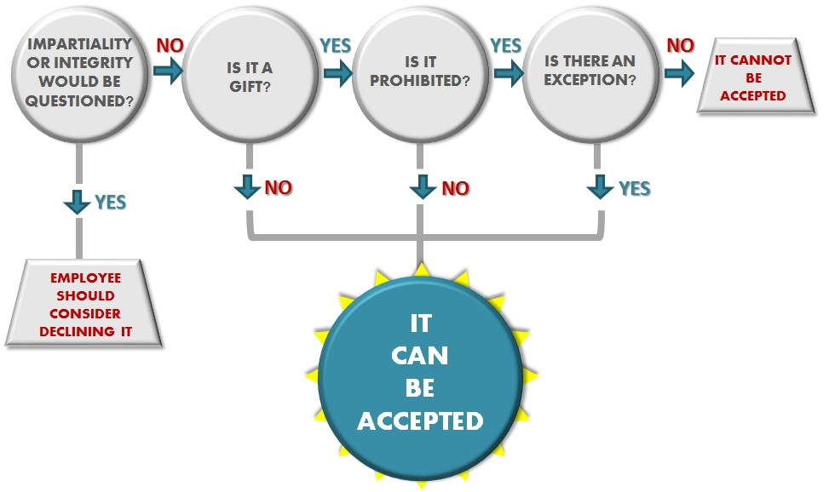
Exclusions (not a gift) | 1. Modest food items  2. Presentation items of little intrinsic value  3. Loans from financial institutions on terms generally available to the public  4. Opportunities/benefits  5. Rewards/prizes | 6. Pensions/other benefits  7. Paid for by the Government  8. Free attendance provided by event sponsor  9. Statutory authority  10. Market value paid

PROHIBITIONS

Standards of Conduct  (all exceptions available)  An employee may not accept a gift:  1. from a prohibited source; or  2. given because of official position. | Ethics Pledge  (use only highlighted exceptions)  An employee may not accept a gift from a registered lobbyist (does not include 501(c)(3) or media organizations unless the organization employee offering the gift is a registered lobbyist).

Exceptions | a) $20 or less  b) Personal Relationship  c) Discounts/Similar Benefits  d) Awards & Honorary Degrees  e) Outside Business/Employment  f) Political Activities  g) Widely Attended Gatherings | h) Social Invitations  i) Foreign Areas  j) President/Vice-President  k) Supplemental Regulation  l) Statutory Authority  m) Informational materials

This is a summary and should not be considered legal advice. When giving advice, always consult the complete text of the laws, rules, and opinions that apply to the situation.

